# Block diagram of system

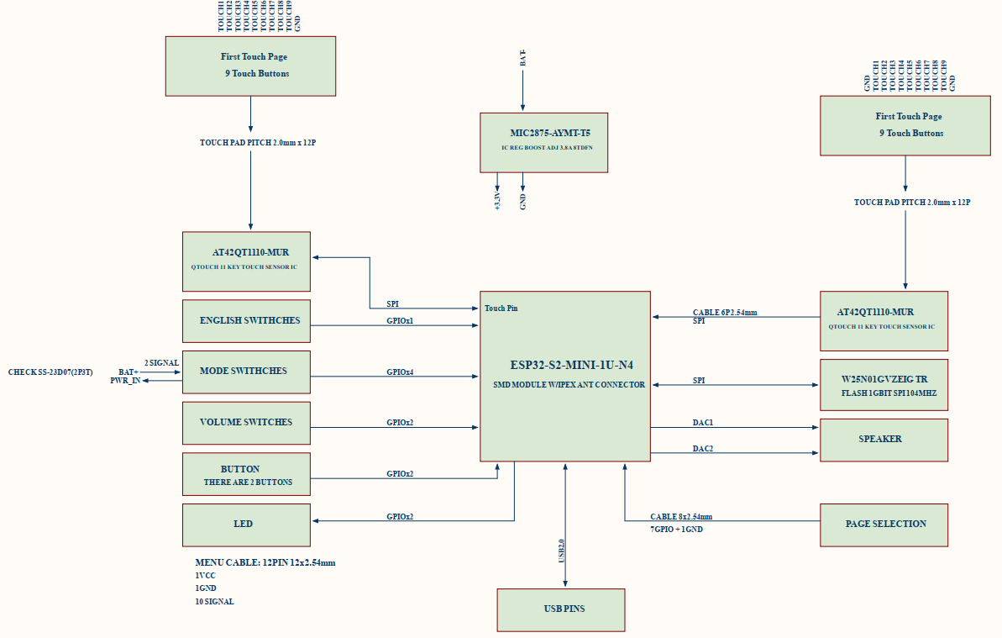

# High level design



Firmware will devide 3 parts:

* Config hardware: this part will initial GPIO, peripheral, interrupt, SPI, I2C … for this project.
* Driver: this part includes the code for the driver of Eink display and BLE communication with IOS app.
* App: this part will use “driver” for coding follow diagram.

# Tools for develop

MCU: esp32-s2 mini

Environments:

* ESP32-IDF platform
* C/C++
* Microsoft Windows.

# Diagram

## Touch recognition



## Hard button detection



## USB interface save flash



## Audio play follow the lesson

